# Self-Organizing Maps

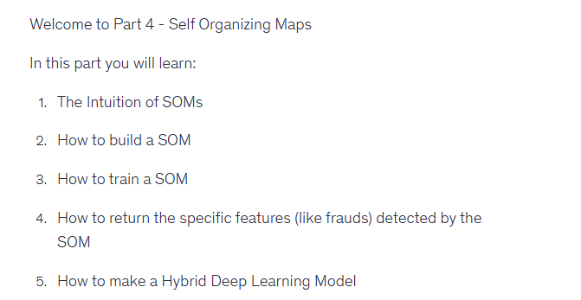



## How do SOMs work?

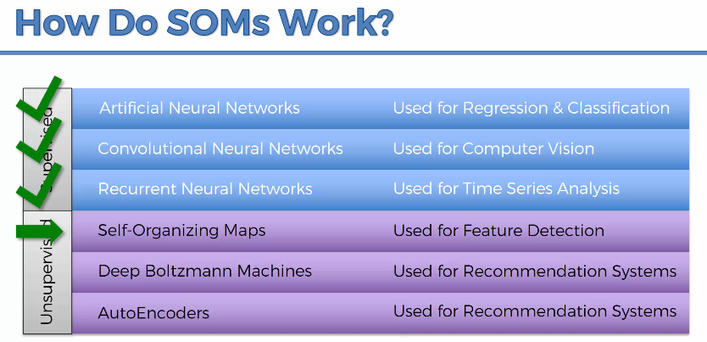

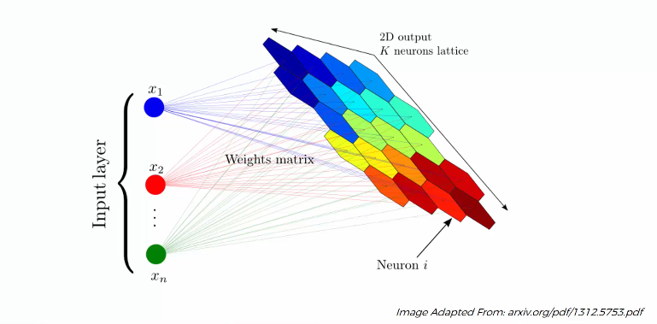

There can be a lot of features in reality. Main intention of SOM is to reduce these number of features by mapping them to 2-D grid of neurons (also called nodes)

